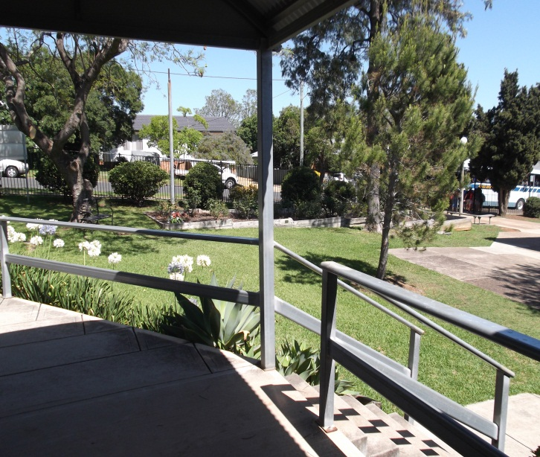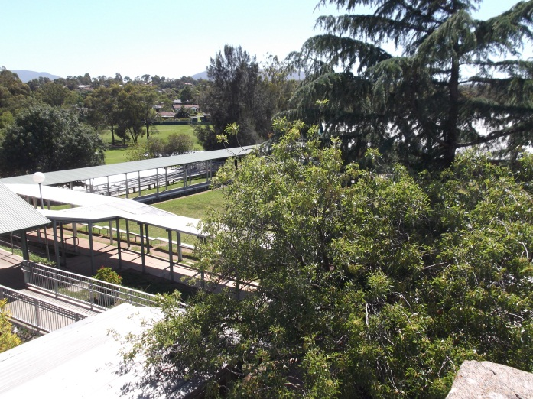

**2688**

Muswellbrook Public School

**Annual School Report 2014**

**[school code]**

School context statement

Muswellbrook Public School is a rural school set in the Hunter Valley, approximately 1.5hrs north-west of Newcastle. Once possessing a stable student enrolment, downturn in the mining sector has resulted in increasing levels of unemployment and residential instability. This has led to significant fluctuations in student enrolment.

Student information

It is a requirement that the reporting of information for all students be consistent with privacy and personal information policies.

Student enrolment profile

|  |  |  |  |  |  |  |
| --- | --- | --- | --- | --- | --- | --- |
| **Gender** | **2009** | **2010** | **2011** | **2012** | **2013** | **2014** |
| **Male** | 315 | 302 | 306 | 312 | 318 | 316 |
| **Female** | 248 | 259 | 257 | 255 | 283 | 283 |

Student attendance profile



Workforce information

It is a requirement that the reporting of information for all staff must be consistent with privacy and personal information policies.

Workforce composition

|  |  |
| --- | --- |
| Position | Number |
| Principal | 1.0 |
| Deputy Principal(s) | 1.0 |
| Assistant Principal(s) | 4.0 |
| Primary executive Release | 1.0 |
| Primary Part-Time Teacher | 1.0 |
| Primary Teacher RFF | 1.05 |
| Classroom Teacher(s) | 18.0 |
| Teacher of Reading Recovery | 0 |
| Learning and Support Teacher(s) | 1.2 |
| Teacher Librarian | 1.0 |
| Teacher of ESL | 0.2 |
| School Counsellor | 1.0 |
| School Administrative & Support Staff | 4.062 |
| Total | 34.312 |

The Australian Education Regulation, 2014 requires schools to report on Aboriginal composition of their workforce.

We remain fortunate to have two Aboriginal teachers on staff that have a combined level of experience of eight years as well as our deputy principal having 20+ years experience. This represents approximately 10% of the workforce.

Teacher qualifications

All teaching staff meet the professional requirements for teaching in NSW public schools.

|  |  |
| --- | --- |
| Qualifications | % of staff |
| Degree or Diploma | 90 |
| Postgraduate | 10 |

Professional learning and teacher accreditation

All staff have participated in the mandatory training requirements that target student/staff health and wellbeing especially those that centre on Workplace Health and Safety. These include First Aid/CPR training, emergency care and Keep Them Safe (child protection) training. Similarly, all staff are up-to-date in their anaphylaxis and asthma training as well as actively participating in emergency evacuation drills when scheduled.

Staff continue to receive training in the use and implementation of the literacy and numeracy continuums. These are now assisting staff in the development of student reports to parents. Consistency in teacher judgement especially in the assessment of students using the curriculum remains an area of focus for 2015. In 2014 $31862 was directed toward teacher training and development.

Beginning Teachers

We have two beginning teachers in receipt of funding to enhance their knowledge and proficiency. One is our librarian while the other is a classroom teacher.

Both staff have participated in mandatory training requirements covering both on-line learning as well as face to face presentations. One staff member has a combined total of 34 hours accreditation including both registered and non-registered hours. The other has 9.5 hours with 3 hours registered and 6.5 hours non-registered. This staff member has had several courses in which she has been enrolled cancelled at the last minute due to low staff numbers attending.

Supporting these staff have been colleagues within their grade as well as their respective stage supervisor. They have actively participated in whole school meetings designed to develop greater understanding of English, mathematics, science and technology as well as the history syllabuses.

Financial summary

This summary covers funds for operating costs and does not involve expenditure areas such as permanent salaries, building and major maintenance. However, it does include an allocation of $100000 to replace/repair assets likely to deteriorate due to age in the next 12 months. This includes electronic interactive technologies, computers as well as the acquisition of classroom blinds and repairs to concrete walkways.

|  |  |
| --- | --- |
| Date of financial summary | 30/11/2014 |
| ***Income*** | $ |
| Balance brought forward | 493142.28 |
| Global funds | 307939.42 |
| Tied funds | 475612.73 |
| School & community sources | 152946.62 |
| Interest | 17462.91 |
| Trust receipts | 16924.75 |
| Canteen | 0.00 |
| Total income | 1464028.71 |
| ***Expenditure*** |  |
| Teaching & learning |  |
| Key learning areas | 30852.13 |
| Excursions | 20938.50 |
| Extracurricular dissections | 85888.08 |
| Library | 9422.79 |
| Training & development | 0.00 |
| Tied funds | 349126.08 |
| Casual relief teachers | 120715.94 |
| Administration & office | 64596.07 |
| School-operated canteen | 0.00 |
| Utilities | 68632.03 |
| Maintenance | 19308.22 |
| Trust accounts | 20405.75 |
| Capital programs | 53278.06 |
| Total expenditure | 843163.65 |
| **Balance carried forward** | 620865.06 |
|  |  |

A full copy of the school’s 2014 financial statement is tabled at the annual general meetings of the P&C Association. Further details concerning the statement can be obtained by contacting the school.

School performance 2014

Academic achievements

NAPLAN

In the National Assessment Program, the results across the Years 3, 5, 7 and 9 literacy and numeracy assessments are reported on a scale from Band 1 to Band 10.

The achievement scale represents increasing levels of skills and understandings demonstrated in these assessments.

Year 3: from Band 1 (lowest) to Band 6 (highest for Year 3)

Year 5: from Band 3 (lowest) to Band 8 (highest for Year 5)

Year 7: from Band 4 (lowest) to Band 9 (highest for Year 7)

Year 9: from Band 5 (lowest) to Band 10 (highest for Year 9)

The *My School* website provides detailed information and data for national literacy and numeracy testing (NAPLAN).

Click on the link <http://www.myschool.edu.au>

and enter the school name in the *Find a school* and select *GO* to access the school data.

Alternatively:

NAPLAN Year 3 - Literacy (including Reading, Writing, Spelling and Grammar and Punctuation)

In Grade 3, 18% of students did not attain minimum National Benchmark standards in Reading compared to 6% (2013) and 10% (2012)). This percentage exceeds state (7%) in 2014.

86% of Grade 3 students attained NBS which was equal to that of 2013 but below the target set of 93%. 37% of Grade 3 students of Grade 3 students scored in the top two skill bands which is the same as in 2013 but more than the 26% in 2012.

91% of Grade 3 students scored at or above NBS compared to 97% (2013) and 91% (2012) with 45% of students scoring in the top two skill bands compared to 36% in 2013.

NAPLAN Year 3 - Numeracy

95% of Grade 3 students met or exceeded NBS. This was 3% below the target set. However this was equal to the State percentage not meeting NBS.

NAPLAN Year 5 - Literacy (including Reading, Writing, Spelling and Grammar and Punctuation)

Similarly, Grade 5 reading results reflect 88% of students attaining or exceeding NBS compared to 97% (2013) and 82% (2012).

These were disappointing results especially when the level of resources significantly increased to support student learning. Perhaps too many strategies were adopted. This will be significantly reduced in 2015 to one reading strategy.

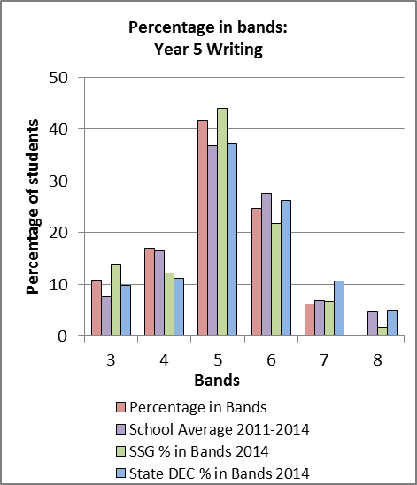

89% of Grade 5 students met NBS compared to 94% (2013), 91% (2012) and 95% (2011).

NAPLAN Year 5 - Numeracy

92% of students in Grade 3 met or exceeded minimum NBS. This similar level was achieved in Grade 5 which was also below the set target of 98%.

Significant programs and initiatives – Policy and equity funding

Aboriginal background

The achievements of our Aboriginal students will be reflected through the Outcomes in School Priority areas identified on pages 4 and 5 of this report. I would however like to include a summation of the achievements of our school’s Yarnup Group in 2014 presented through the President.

* Cultural links continue to be established reflected in 2014 through our Reconciliation Assembly in which Sonia Sharpe (Hunter Aboriginal Community Liaison Officer) presented her address focusing on the importance of reconciliation.
* Parents and some staff developed and implemented an educational package which was presented to all staff to help them understand and give them knowledge on the indigenous culture. This was not only gratefully received but has been transferred into classroom practice and program design.
* All indigenous students were invited to participate in the Bangara Dance Workshop which was a great initiative and the children loved it.
* NAIDOC Day was a great success with a lot of support from volunteers for the day
* A Year 6 transition program targeting vulnerable Aboriginal students commenced which has made the adjustment to high school a little easier for many.
* Community and staff worked together to realise the installation of a second flag pole enabling the Aboriginal flag to be flown alongside the Australian flag every day.
* Bringing cultural awareness to the whole school community through discussions and community events.
* A School Learning Support Officer (SLSO) was employed using monies received through Resource Allocation Model (RAM – Aboriginal Education). Aboriginal students were targeted in writing to develop their skills as well as establishing links to local culture and Dreamtime stories. Due to illness this program was cut short this year however permission has been received to carry unspent monies into 2015 to enable this program to continue.
* Personalised Learning Plans were developed catering for individual student need. These were developed in conversations held between student, parent and teacher.
* Year 6 children were invited to attend and participate in an educational workshop designed to give them confidence and to develop future plans, establish goals and how best to achieve them.
* Building our children’s pride and knowledge in their culture while seeing them participate in the school activities.

Multicultural education and anti-racism

We continue to enjoy growing numbers of students whose families originate from countries outside of Australia. They bring with them their heritage and culture from which we all benefit.

As part of the Anti-Racism Policy our school has a zero tolerance towards all types of bullying or racism and students are actively encouraged to report any instances or concerns with respect to racist behaviour to our school’s Anti-Racism Officer, Ms Anne Downes (Deputy Principal).

Socio-economic background

Our school has a growing need to ensure equity programs are implemented. The dynamics of Muswellbrook Public School has changed in recent years with the receipt of funding support through the Resource Allocation Model (RAM). This has enabled staff to cater for growing individual and group need.

SLS Officers were employed to support students where classes exceeded maximum recommended numbers. Officers undertook work with students experiencing special need support as well as working with students requiring extension.

Several students in the younger years displayed behaviour that is not acceptable at school. These students were also supported in the provision of social programs during times of daily play to teach them how to mix socially and about responsible play.

Money has been carried over to 2015 to implement a speech and occupational therapy program provided by local professionals. This will be presented to school staff during identified staff development days with funding used to cover costs of training, travel and wages of these professionals. Training was not available in 2014 to upskill staff.

A significant proportion of funds were allocated to the employment of SLSOs to support students who were just below their grade PM benchmark levels. This technique proved very successful as most students quickly developed the additional skills needed to reach their grade target level.

Funds also targeted issues surrounding welfare. Downturn in the local mining and related industries realized an increase in families requiring support to participate in excursions, purchase school uniforms as well as offering breakfast and homework programs.

Unspent funds have been carried over to support families in the purchase of required texts planned for introduction in 2015. These are designed to improve student outcomes in mathematics.

Additional programs have been introduced to improve literacy and numeracy outcomes. These have included Mathletics, Fast for Word, TEN as well as a Phonemic Awareness Program specifically for kindergarten students. It is anticipated that positive results will be reflected in 2015 data.

English language proficiency

Two students received English as a Second Language (ESL) support. Through the employment of a teacher the Kindergarten student now recognize all sounds and can recall a growing range of sight words. The interpretation of English particularly in social settings appears to now be the main stumbling block. The use of language is not fluent and so can be quite difficult to understand. Targets for 2015 will include the development of communication techniques especially in social context, increasing reading strategies and to confidently count to 100.

The second student has progressed wonderfully. He is in Year 3 and has a growing understanding and use of English especially in the social setting. This student received his grade’s academic award for 2014. This is a spectacular achievement as a result of natural ability and the support provided by the funding of this program.

Learning and Support

The use and implementation of Individual Education Plans has directed attention toward specific learning need. All students in receipt of funding assistance have a developed personalised learning plan. Students who have special learning needs but who are not receiving funding support are provided this through modifications in the class teaching program.

Teachers have received training in the use of both the Literacy and Numeracy Continuums. This has supported the accurate placement of students within respective clusters that has easily been reported to parents.

As recognised through RAM Funding, professional learning was allocated to cater for students with speech and occupational therapy needs. This was reported in socio-economic background.

School planning and evaluation 2012—2014

School evaluation processes

NSW public schools conduct evaluations to support the effective implementation of the school plan. The processes used include:

* Surveys to students, staff and parents
* Analysis of data from national assessments (NAPLAN)

In general, student outcomes continue to fluctuate dependent upon cohort. However, an overall reduced level of performance is also evident. This may be as a result of trying to do too many strategies designed to support student learning leading to teacher confusion resulting in little long-term benefit being gained. This will be changed from 2015 when a significantly reduced number of strategies will be introduced into each class teaching and learning program.

There were 455 surveys distributed to parents with 95 returned. This reflects a return rate of 21%. Forming accurate opinions based on this low return rate may be difficult. What may be said that of the surveys distributed, the majority of parents felt disinclined for one reason or another to voice their opinions.

Overall, 88% of parents believed their child’s classroom is an interesting place to learn and 93% believing the school has high expectations for each student. What was a concern was that only 75% of parents believed their child’s teacher talked to them about their learning.

When students were surveyed 84% of Grade 4 believed their classroom was an interesting place to learn compared with 79% of Grade 6 students thinking likewise. 94 – 97% of students in both grades believed their school held high expectations for them to do their best. This transferred into 96% of Grade 4 believing they actually do try their best and take pride in their work compared to 95% of grade 6 students. Most interesting is the belief that only 23% of students in both grades believe their teachers discuss their progress with their parents.

This highlights an important aspect of our role as teachers which is the conveyancing of accurate information to parents regarding the performance of their children against identified outcomes.

School planning 2012-2014:

School priority 1

Improve the Literacy outcomes of all students

Data over recent years has focused on the need to improve the reading, writing, spelling as well as grammar and punctuation skills of students. To this end, recent and future reports will continue to focus on the acquisition of these skills.

**Literacy – NAPLAN Year 3**

Similar patterns were reflected in writing results. 8% of students did not attain minimum National Benchmark standards compared to 5% (state) in 2014.

Literacy – NAPLAN Year 5

In Grade 5, 12% of students did not attain minimum National Benchmark standards in Reading compared to 3% (2013) and 16% (2011). This percentage is also higher than that of state (7%) and similar to schools in this area (12%).

|  |  |  |  |  |  |
| --- | --- | --- | --- | --- | --- |
| **Average progress in Reading between Year 3 and 5\*** | | | | | |
|
|  | **2008-2010** | **2009-2011** | **2010-2012** | **2011-2013** | **2012-2014** |
| **School** | 100.9 | 95.5 | 74.8 | 82.7 | 97.6 |
| **SSG** | 80.1 | 76.9 | 85.7 | 88.6 | 76.2 |
| **State DEC** | 83.7 | 74.0 | 79.2 | 85.7 | 78.78 |

Similar patterns were reflected in writing results. 11% of students did not attain minimum National Benchmark standards compared 9% (state) but significantly better than schools in this area (14%).

Outcomes from 2012–2014

Reading:

A reduction in the numbers of students scoring in the top two skill bands was also evident. 27% of students in Grade 3 compared to 39% (2013) and 29% (2012). In Grade 5, 44% scored from Band 6 or higher compared to 63% (2013), 36% (2012) and 63% (2011).

In 2014 98% of Grade 7 students reached at or above NBS with 17% scoring in the top two skill bands compared to 16% (2013) and 24% (2012).

Of the ATSI students in Grade 3, 14% failed to meet NBS in 2014 compared to 33% (2013) and 17% (2012). This trend was reversed in Grade 5 as 19% failed to meet minimum NBS compared to 13% (2013) and 29% (2012). No students scored in the two top skill bands in either Grade 3 or 5.

100% of Grade 7 ATSI students reached or exceeded NBS which matched 2013 results and again exceeded 2012 (75%). 25% of students scored in the top two skill bands compared to no students in 2013 and 13% (2012).

Writing:

93% of Grade 3 students reached or exceeded NBS compared to 95% (2013), 97% (2012) and 99% (2011) with 89% of Grade 5 students doing likewise compared to 94% (2013), 91% (2012) and 95% (2011). 26% of Grade 3 students achieved in the top two skill bands compared to 31% (2013), 36% (2012) which is the same as in 2011 while 6% of Grade 5 students did likewise compared to 12% (2013), 5% (2012) and 27% (2011).

86% of ATSI students in Grade 3 scored above minimum benchmark levels in writing compared to 83% (2013) while 100% of ATSI students in Grade 5 compared to 85% (2013).

No ATSI students scored in the top two skill bands in either Grade 3 or Grade 5 compared to one student in each grade in 2013.

87% of ATSI students in Grade 7 achieved at or above NBS compared to 100% (2013) and 62% (2012). However no student scored in the top two skill bands.

Spelling:

86% of Grade 3 students attained NBS which was equal to that of 2013 but below the target set of 93%. 91% of Grade 5 students reached NBS compared to 95% (2013) which is 2% less than the set target of 93%. 37% of Grade 3 students of Grade 3 students scored in the top two skill bands which is the same as in 2013 but more than the 26% in 2012. 27% of Grade 5 students achieved the top two skill bands compared to 33% (2013) and 28% in 2012.

82% of Grade 7 students achieved NBS as opposed to 94% in 2013. The ATSI students in Grade 7 all achieved at or above NBS.

Grammar and Punctuation:

86% of Grade 5 students scored above minimum NBS which is 10% less than 2013 figures. However 21% scored in the top two skill bands.

In Grade 7, 84% met anticipated outcomes from the DEC compared to 85% in 2013 while 15% scored in the top two skill bands compared to 13% (2013) and 31% in 2012.

Strategies to achieve these outcomes in 2014:

* All class teachers will be expected to assess students based on all aspects of the Literacy Continuum
* Visitations to schools demonstrating best practice
* Purchase of resources designed to support the explicit teaching of comprehension
* Training and development of the new English syllabus
* Targeting the explicit teaching of inferential and interpreting questions within the reading program
* Continuation of L3 and Best Start Programs in ES1 and S1
* Practical writing activities will focus on teacher modelling followed by guided and independent writing activities undertaken regularly
* Samples of best practice from within and beyond the classroom will be utilised to sustain interest and enthusiasm
* School editing checklist being implemented K-6
* Students being provided with specific criteria leading to writing improvement based on grade writing rubric assessment guides
* Students critically analyse own as well as other samples of work
* Linking of pre and post writing samples to establish starting levels for students writing
* Revisit rubrics to ensure thorough student and teacher understanding

School priority 2

Improved understandings in mathematics will be reflected through Naplan results in 2013

Outcomes from 2012–2014

* 95% of Grade 3 students met or exceeded NBS. This was 3% below the target set. However this was equal to the State percentage not meeting NBS.
* 92% of students achieved likewise in Grade 5 which was also below the set target of 98%.
* 23% of students in Grade 3 achieved skill bands 5 and 6 compared to the target of 32%
* 8% of students in Grade 5 achieved skill bands 7 and 8 compared to the target of 20%
* All ATSI students in Grade 3 met or exceeded minimum NBS and this trend was reflected in Grade 5 results.
* No ATSI students scored in the top two skill bands in either Grade 3 or Grade 5 compared to the target of 28%

**Strategies to achieve these outcomes in 2014:**

* All class teachers will be expected to assess students based on all aspects of the Numeracy Continuum
* Implementation of the MPS K-6 Maths Program will be maintained
* Stage meetings are held regularly to maintain consistency in assessment
* Further resources including hands on equipment and resources to generate open ended investigations will be purchased and developed to support the MPS K-6 Maths Program **t**o enhancelearning opportunities.

School priority 3

Students will reflect greater resiliency when dealing with issues of bullying within and beyond the school

Outcomes from 2012–2014

* The issuing of red cards to students for deliberate acts of bullying increased in Term 2 of 2014. This exceeded the average for the last 5 years of 17 by a staggering 22 cards. This only emphasizes the need to implement the strong values centred Kidsmatter Framework starting from Term 1 2015.
* The implementation of the Kidsmatter Framework was delayed through training requirements to be completed from the facilitators.

**Strategies to achieve these outcomes in 2014:**

* Implementation of Module 1 and 2 of KidsMatter Framework to support student welfare
* T&D meetings will be held regularly to maintain consistency in the presentation of the program and to identify ongoing issues
* Weekly **Welfare** meetings will continue to be held to promote proactive procedures in dealing with welfare concerns
* A classroom teacher continues to be released one day each week to support students in their attendance and ongoing welfare concerns
* Ongoing analysis of the Card System focusing on consequences of behavior targeting restorative justice

Parent/caregiver, student, and teacher satisfaction

In 2014, the school sought the opinions of parents, students and teachers about the school.

Their responses are presented below.

As mentioned earlier in this report less than 21% of parental survey responses were returned. Therefore any conclusion with regard to school culture should be viewed with some scepticism.

The majority of parental responses believed that the school makes consistent effort to know the families and community in which it serves (92%). The same percentage reflects their opinions that school leadership has a positive influence on school culture.

A significant number (96%) are of the opinion that the school praises and rewards students who are successful however one response felt this only applied to sporting prowess rather than academic. 98% believed that our school’s main concern was for its students.

Interestingly was the response to the question whether parental support was positive for the school. 77% of responses believed it was worthwhile and 23% felt it could be a lot better. This will be an area for further examination in 2015.

91% were of the opinion that our school encourages new students and their families to be involved in school activities with 95% believing our school encourages their children to do their best.

Aspects of the survey failed to obtain some responses as parents felt they did not know enough about the questions. This includes “the school is continually finding ways to improve what it does” (although 92% of responses thought it did) while another “when necessary, the school makes important changes to what it does” had similar results.

This information however does highlight the need to openly communicate to parents about the practices that are being undertaken to accurately evaluate our teaching and learning processes.

Future Directions

2015-2017 School Plan

NSW DEC is implementing a new school planning process for 2015-17. The new plan will be published on the school’s website from the beginning of Term 2 2015.

Our school is currently holding conversation with its students, staff and parent body to identify their individual and collective vision for the future. These will be presented as part of the 2015-2017 Strategic Plan.

About this report

In preparing this report, the self-evaluation committee has gathered information from evaluations conducted during the year and analysed other information about the school's practices and student learning outcomes. The self-evaluation committee and school planning committee have determined targets for the school's future development.

John Fibbins Principal

Anne Downes Deputy Principal

Christine Rankin Ass. Principal

Paul McLeod Ass. Principal

Wendy Nougher Ass. Principal

Ebonie Barnett Rel. Ass. Principal

School contact information

Muswellbrook Public School

Roger Street

Muswellbrook NSW 2333

Ph: 65432500

Fax: 65433378

Email: muswellbro-p.school@det.nsw.edu.au

Web: www.muswellbro-p.school.nsw.edu.au

School Code: 2688

Parents can find more information about Annual School Reports, how to interpret information in the report and have the opportunity to provide feedback about the report at:

<http://www.schools.nsw.edu.au/learning/emsad/asr/index.php>